**[Ping(Packet Internet Groper)](https://www.geeksforgeeks.org/ping-command-in-linux-with-examples/" \t "_blank)**

ping command is used to ensure that a computer can communicate to a specified device over the network. ping command sends Internet Control Message Protocol(ICMP) Echo Request messages in the form of packets to the destination computer and waits in order to get the response back. Once the packets are received by the destined computer, it starts sending the packets back. This command keeps executing until it *si* interrupted.

**ping command provides details such as**

* number of packets transmitted
* number of packets received
* time taken by the packet to return

**ping command in generally used for the following purposes:**

* measuring the time taken by the packets to return to determine speed of the connection
* to make sure that the network connection between host and the destined computer can be established

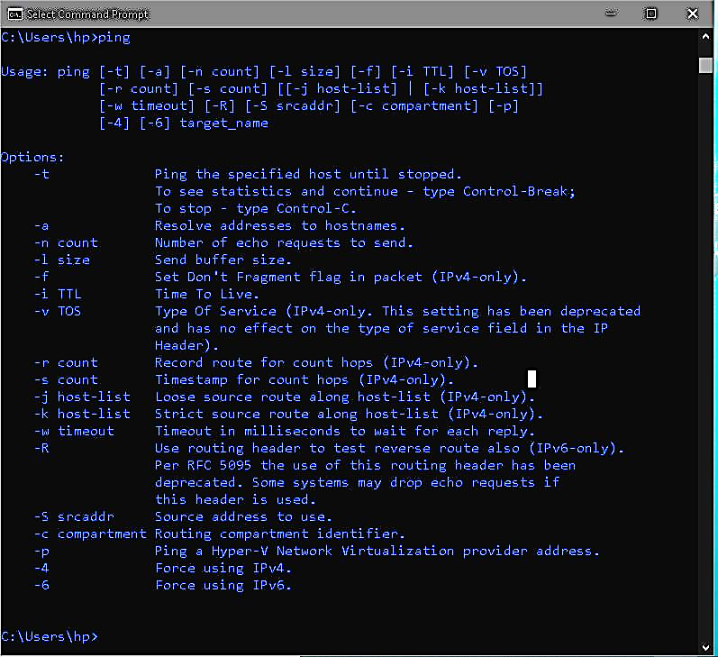**Usage**

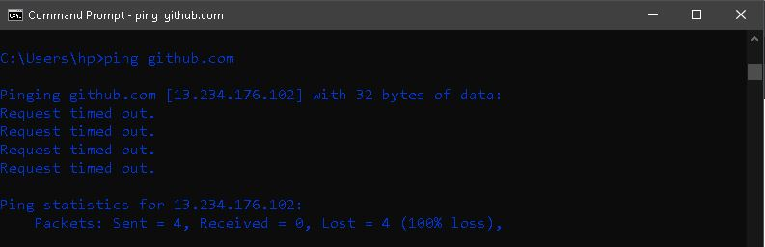

[**traceroute**](https://www.geeksforgeeks.org/traceroute-command-in-linux-with-examples/)

This command is used to get the route of a packet. In other words, traceroute command is used to determine the path along which a packet travels. It also returns the number of hops taken by the packet to reach the destination. This command prints to the console, a list of hosts through which the packet travels in order to the destination.

[**netstat**](https://www.geeksforgeeks.org/netstat-command-linux/)

netstat(Network Statistics) is the command that is used to display routing table, connection information, the status of ports, etc. This command works with Linux Network Subsystem. This command basically displays the content of /proc/net file defined in the Linux file system.

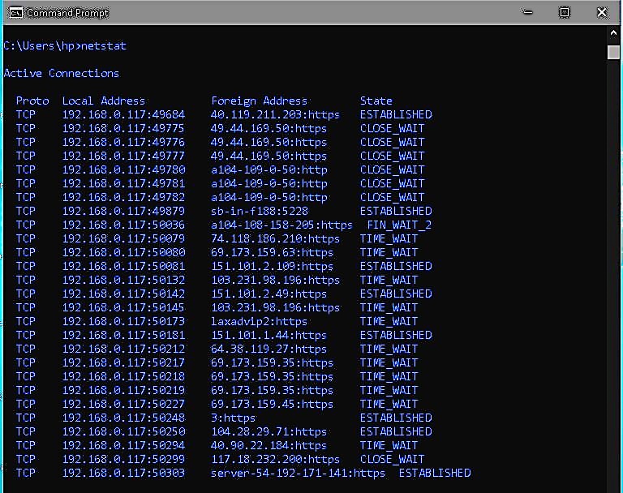

**Usage with example (netstat -r)**

